

EXCALIDRAW DEVELOPMENT AND INTEGRATION

Software Engineering (CMR UNIVERSITY)

Scan to open the Doc

1


EXCALIDRAW DEVELOPMENT AND INTEGRATION

SOFTWARE ENGINEERING


SUBMITTED BY -

1) SATHYA GYNAN -23BBTCS215 2) RICKIE JOHN - 23BBTCS188

3) SHAUN SOLOMON -23BBTCS222 4) SHREE SAGAR Y N -23BBTCS227

5) RITHIK SHARMA - 23BBTCS220

To
Prof. Rajani Kodagali

CMR UNIVERSITY BENGALURU, INDIA

2


INDEX
- PROBLEM ANALYSIS ………………………………………………………… 3-6
  - Abstract
  - Identification of project scope:
  - Objectives
  - Infrastructure
- SOFTWARE REQUIREMENT ANALYSIS AND PLANNING 7-12
  - Description of individual phase/module:
    - User characteristics
    - General constraints
    - Assumption
    - Functional requirements: -Input, Output, Description
    - Identify Individual Module Deliverables
- DATA MODELING… 13-26
  - System Architecture Design
  - Use Case Diagram
  - Activity Diagram
  - DFD Diagram
- DEVELOPMENT… 27-29
  - Code structure and repository overview
  - Development environment setup
  - Main technologies used
  - Component implementation
  - Customisation possibilities
  - Contribution workflow
- SOFTWARE TESTING… 30-33
  - Test results and debugging

- PROJECT DEMO… 34-35
  - Screen shots

- CONCLUSION… 37

3


PROBLEM ANALYSIS:

Abstract:
Excalidraw is an open-source virtual whiteboarding tool built with React, designed for sketching diagrams with a hand-drawn feel. It supports real-time collaboration, easy integration, and customization, making it ideal for developers and teams. This project focuses on understanding Excalidraw's architecture, setting up the development environment, and exploring its integration into web applications. Although no new features were added, the work emphasizes software engineering practices and the software development life cycle (SDLC), offering insight into Excalidraw’s modular design and development process.

Overview of the Project:
Excalidraw fills a critical gap in digital collaboration. Traditional whiteboard tools are often locked behind subscriptions, limited feature sets, or lack of extensibility. Excalidraw is
open-source, feature-rich, and embeddable, making it an ideal tool for developers and teams to customize and deploy.
It allows users to draw on a canvas that mimics hand-drawn visuals. Elements such as rectangles, arrows, free-hand strokes, and text boxes can be created and manipulated. It supports collaboration and local storage of files, enhancing real-time work.

Identification of project scope:
This project explores Excalidraw from a development standpoint. It includes:

- Cloning and running the source code locally

- Understanding modular structure

- Identifying key components like the canvas, UI layout, and state management

- Investigating the code base using tools like Git, Yarn, and Node

- Creating sample integrations using npm and embedding into a React-based web application

Task involved:
- Drawing Management: Handles shape creation and rendering on the canvas.

- State Management: Maintains tool selection, element data, and history.

- Collaboration: Enables real-time editing with multiple users.

4


- Export & Storage: Supports saving to local storage and exporting as PNG/SVG.
- Embedding: Allows integration into other apps using the React component.

Objectives:
    - Benefits of Using and Understanding Excalidraw
We’ve highlighted the significance of Excalidraw as a collaborative whiteboarding tool. This section outlines the key benefits of integrating, exploring, or contributing to Excalidraw and its impact on digital collaboration and diagramming tools from a software engineering perspective.

Easy Diagram Data Retrieval
Excalidraw allows users to access previously created drawings easily. With features like saving to local storage, exporting JSON, and loading scenes, users can retrieve diagrams, revisit changes, and collaborate on updates seamlessly.

Built-in Scene & Canvas Management
Every drawing (scene) is stored with complete metadata such as shapes, styles, positioning, and annotations. These can be restored or shared via JSON files, giving full control over the canvas data.

Increased Data Security
While Excalidraw is client-side by default, it supports private usage with local storage.
Developers can also implement secure, cloud-based backups, ensuring that sensitive diagrams or flowcharts are protected and accessed only by authorized users.

Improved UI Transparency and Simplicity
Excalidraw provides a minimal, intuitive interface that ensures clarity and ease-of-use for all users. Every tool and function is accessible, with transparent actions and expected behaviors during drawing, editing, or exporting.

Streamlined Collaboration & Reporting
The built-in support for real-time collaboration allows teams to work together on diagrams.

5


Changes are reflected instantly, making reporting and version tracking simple and efficient.

Improved Code & Contribution Quality
By studying Excalidraw’s codebase, developers gain insight into best practices in modular design, state management, and performance optimization, thereby encouraging cleaner and more maintainable code in their own projects.

Enhanced Visibility for Developers
The modular architecture improves developer visibility into every component—whether it’s rendering, state logic, or UI behavior. This makes debugging, extending, or integrating
Excalidraw much easier.

Easy Access and Integration
Excalidraw is available as a standalone app or an embeddable React component. Developers can integrate it into their applications with just a few lines of code, and easily customize it using available APIs.

Cost-Effective and Open-Source
As a free, open-source tool, Excalidraw eliminates licensing costs. It reduces the need for custom diagramming solutions and cuts down development time when integrating drawing tools in larger apps.

Infrastructure:
    - Hardware Requirements:
- Processor: 2.0 GHz Dual Core (minimum)
- RAM: 4GB (8GB recommended)
- Disk: 1 GB free space
- Network: Internet access to clone repo and install dependencies

Software Requirements: (Any one of these)
- OS: Windows/macOS/Linux
- Node.js and npm
- Yarn (v1 or v2/Berry)
- Git (for version control)
- Visual Studio Code or equivalent IDE
- Modern browser (Chrome/Firefox)
6


Software Requirement Analysis And Planning
  - Description of individual phase/module
In the context of Excalidraw, the system is modular and component-driven. The following are identified as the core components/modules:

Canvas Renderer Module
Responsible for drawing shapes (rectangles, ellipses, arrows, freehand lines, text, etc.) on a virtual canvas. It uses SVG + HTML5 Canvas and ensures that drawing operations appear sketchy and hand-drawn.

Element Management Module
Handles creation, editing, deletion, selection, and movement of elements. Each element has properties such as type, stroke color, background color, and coordinates.

User Interface (UI) Module
Built using React components. It includes the top bar (tools like selection, rectangle, arrow), the side panel (element properties), and file options (load, save, export to PNG/SVG).

Collaboration & Storage Module
Handles file saving (via browser storage, cloud, or export). Also supports collaborative drawing sessions using WebSockets or peer-to-peer via external integrations.

Integration API Module
A library that allows developers to embed Excalidraw as a component into other React apps. Provides methods like onChange, initialData, and others to control behavior from the parent app.

User characteristics
    - Developer
- Integrates or extends Excalidraw within their own applications or platforms.
- Requires strong proficiency in React, JavaScript, and npm ecosystem.
- Needs clear API documentation and modular architecture for easy customization.
- Interested in component reusability and embedding capabilities.
- May use TypeScript for safer development and integration.

7


- Expects code stability and regular updates for long-term projects.

End User
- Accesses Excalidraw through a web browser without any installation.
- Requires a clean, intuitive user interface for ease of use.
- Expects real-time responsiveness and smooth performance across devices (mobile, tablet, desktop).
- May or may not have prior design or drawing experience.
- Prefers minimal learning curve and quick access to basic functionalities.
- Appreciates features like undo/redo, autosave, and collaborative editing.

Contributors
- Open-source developers interested in improving Excalidraw.
- Analyzes the codebase to fix bugs, enhance features, or optimize performance.
- Requires clear contribution guidelines, issue tracking, and code comments.
- Often works with GitHub and may collaborate through pull requests and code reviews.
- Expects a well-organized project structure and readable code for effective contribution.
- May suggest or implement new features, performance improvements, or UI/UX enhancements.

General constraints:
- The application is browser-based and responsive.
- Code must follow React best practices.
- Works with localStorage and optionally cloud backends.
- Dependencies must be managed via Yarn or npm.
- Licensing: MIT License.

Assumptions:
- Users have modern browsers with JavaScript enabled.
- Developers will have a basic understanding of React.
- Network connectivity is available for collaboration features.

Dependency:
- @excalidraw/excalidraw npm package
- React (v17+)
- Yarn and Node.js for local development

8


  - Functional Requirements:

Featu re | Input / Action | Output / Behavior | Description
Draw Shap e | Select shape tool (rectangle, ellipse, etc.) and click or drag on canvas | Shape appears at the selected location on the canvas | Allows users to create visual elements using various shape tools
Move Elem ent | Click on an element and drag to new location | Element moves and updates its position on the canvas | Enables repositioning of drawn elements for better layout and organization
Resiz e Elem ent | Drag corner or edge of selected element | Element resizes accordingly | Supports scaling of shapes to adjust dimensions as needed
Delet e Elem ent | Select element and press delete or click trash icon | Element is removed from canvas | Allows users to remove unnecessary or unwanted elements
Expor t Drawi ng | Click "Export as PNG/SVG" in menu | Drawing is downloaded as image file | Enables users to save their work as image files for sharing or documentation
Save to Local Stora ge | Auto-save occurs during drawing or editing | Data is stored in browser's localStorage | Ensures progress is preserved without manual saves
Load from Local Stora ge | Open app in same browser where data was saved | Previous drawing automatically loads | Automatically restores the last saved canvas from localStorage
Embe d Comp onent | Use <Excalidraw /> in React code | Full editor renders in React app | Allows developers to integrate Excalidraw into their own web applications
Undo  / Redo | Click undo/redo buttons or use Ctrl+Z / Ctrl+Y | Recent action is reversed or redone | Helps users fix mistakes or revisit previous states of their drawing
Colla borat ive Mode | Enable collaboration and share session link | Multiple users edit canvas in real time | Supports real-time drawing with others for teamwork or brainstorming sessions

9


  - Identify Individual Module Deliverables

User Registration

Description
New users can create an account to save their drawings, collaborate in
real-time, and manage personal settings. The user information is stored in the Excalidraw database or local storage (depending on configuration).

Pre - Condition
User must not be already registered. Mandatory fields (like username and password) must be completed.

Main FLow Of Events
        - User selects “Sign Up” from the login module.
        - A registration form is displayed.
        - User fills required details (email, username, password).
        - Account is created and user is redirected to the dashboard.

Post- Condition
User data is saved to the database/local storage, and user gains access to Excalidraw features.

User Profile Updation

Description
Users can update their profile details, such as display name, preferences, and collaboration settings.

Pre- Condition
User must be logged in. Only non-critical profile information can be updated (e.g., username, avatar, preferences).

Main Flow Of Events
        - User logs in.
        - Navigates to profile settings.
        - Modifies necessary fields.
        - Submits updated details.

Post- Condition
User’s updated profile is reflected in the system.

    - Canvas/ Drawing Module

10


Description
Allows users to create, modify, and save diagrams using the drawing tools (e.g., shapes, text, arrows, hand-drawn elements).

Pre- Condition
User must be logged in or working in guest mode. Drawing interface must be fully loaded.

Main Flow Of Events
        - User accesses the canvas.
        - User selects drawing tools (e.g., rectangle, pencil, text).
        - Elements are added to canvas.
        - Users can undo/redo, move, or delete elements.
        - Drawing can be saved/exported.

Post- Condition
Scene data is saved in local storage or uploaded via cloud API, if configured.

Real- Time Collaboration Module

Description
Enables multiple users to work on the same drawing in real-time using collaboration links.

Pre - Condition
Users must be working in a collaboration session. A session ID must be generated and shared.
      - MAIN FLOW OF EVENTS
        - User starts or joins a collaboration session.
        - Other users access the shared link.
        - All participants edit the canvas simultaneously.
        - Changes reflect live on each user's screen.

Post- Condition
All updates are reflected in the shared session; data is synced across users.

Export/ Import Module

Description
Users can export their drawings in various formats (PNG, SVG, JSON) and re-import them for future editing.

11


Pre- Condition
User must have a drawing on the canvas.

Main Flow Of Events
        - User clicks on “Export” or “Save”.
        - Chooses export format.
        - File is generated and downloaded.
        - For import: User selects JSON file and loads it into the canvas.

Post- Condition
Drawing is downloaded or reloaded onto the canvas.

Admin Module (for Hosted/Enterprise Versions)

Description
Admins can manage users, control access levels, and monitor usage analytics.

Pre- Condition
Admin must log in with proper credentials.

Main Flow Of Events
        - Admin logs in.
        - Views user list and activity logs.
        - Updates user permissions or removes accounts.
        - Monitors system usage and performance.

Post- Condition
Admin changes are reflected in the central database.

12


- Data Modelling:

  - System Architecture Diagram :
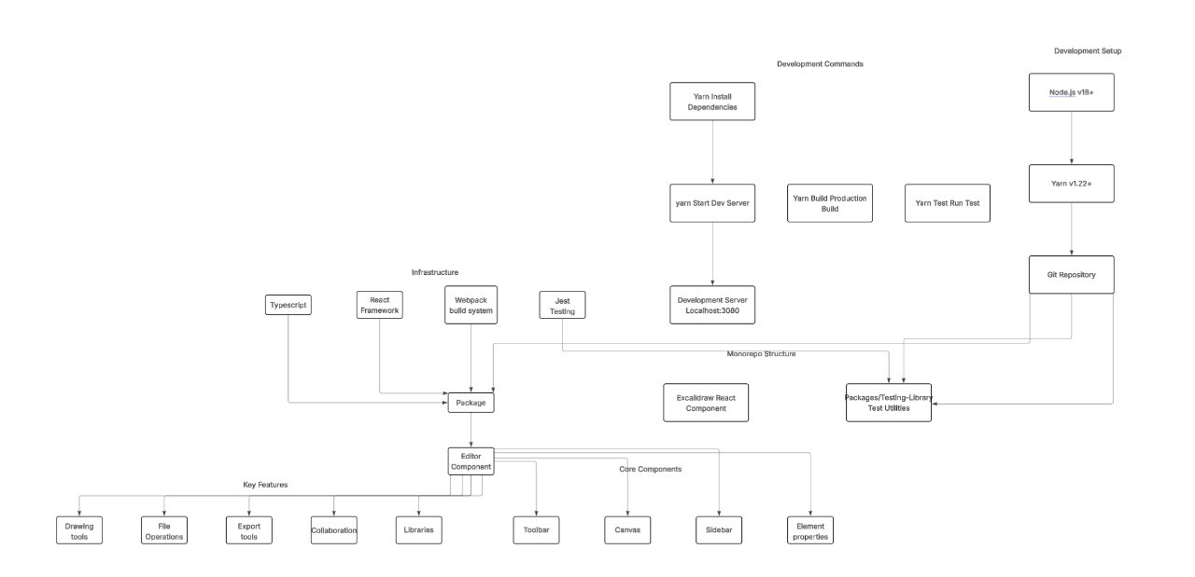

  - Use Case Diagram
    - End User
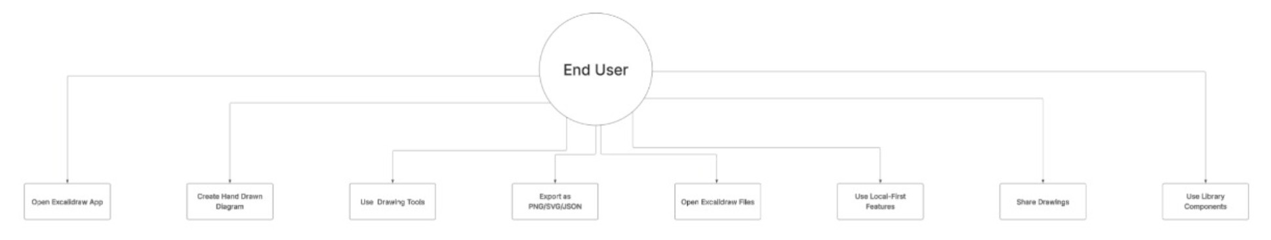

13



    - Open Source Contributor

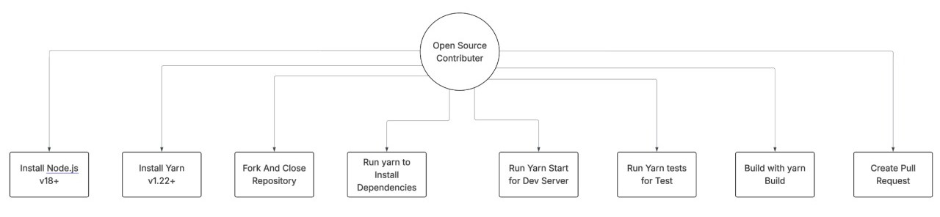

    - Package User/Developer

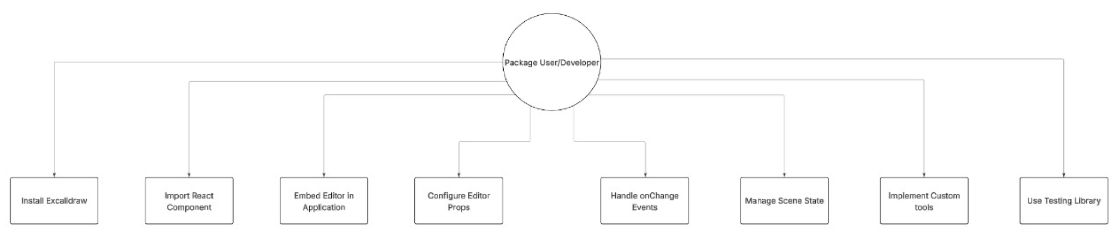

14


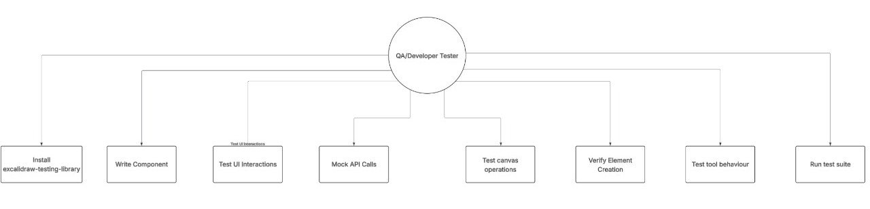
    - Package User/Developer

15


  - Activity Diagram:

    - Developer Integrating Excalidraw Package

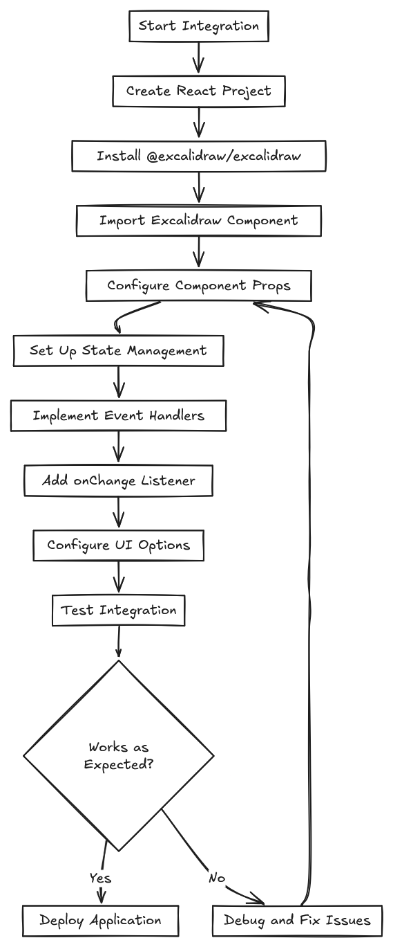

16


    - Excalidraw Development Structure

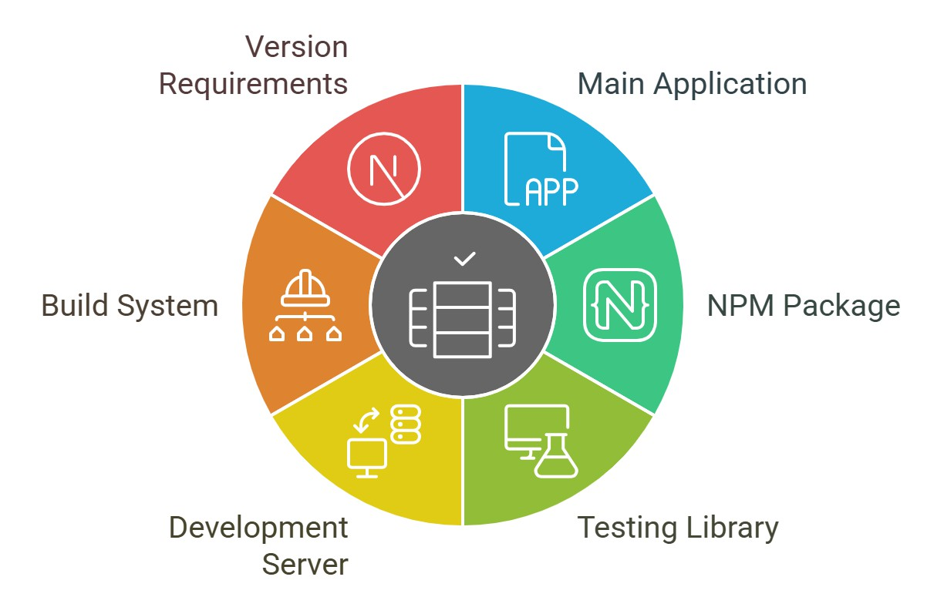

17


    - User Creating a Diagram:
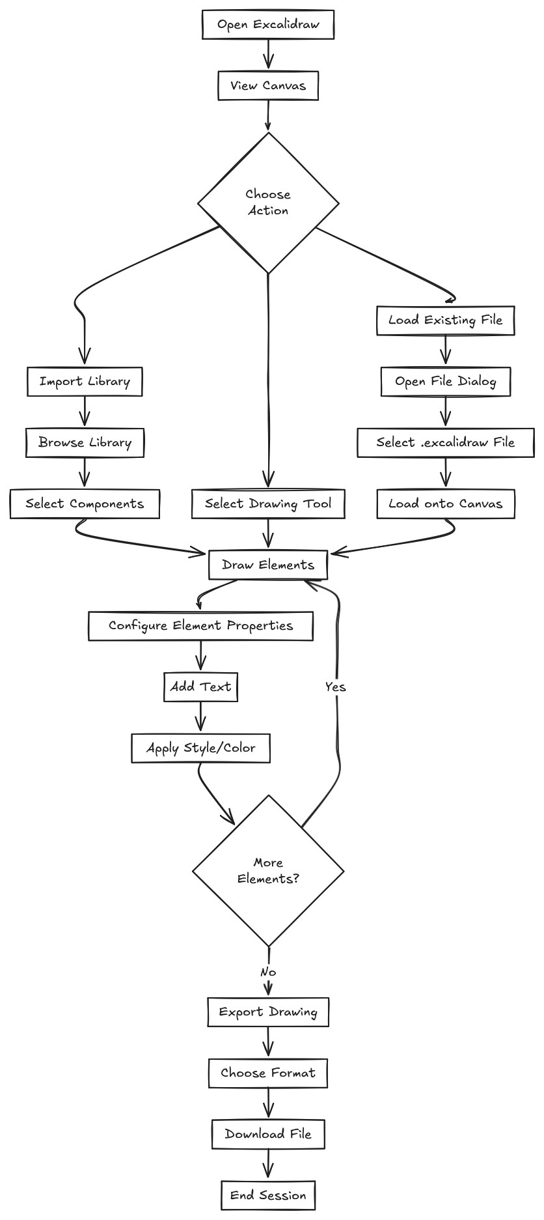

18


  - Data Flow Diagram (DFD):
    - Understanding Excalidraw Development
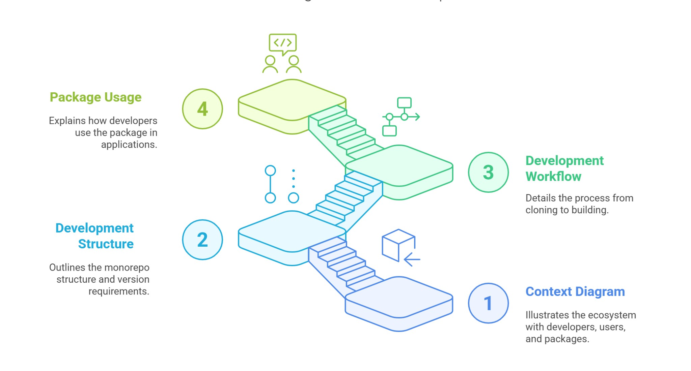

    - Tests for Excalidraw
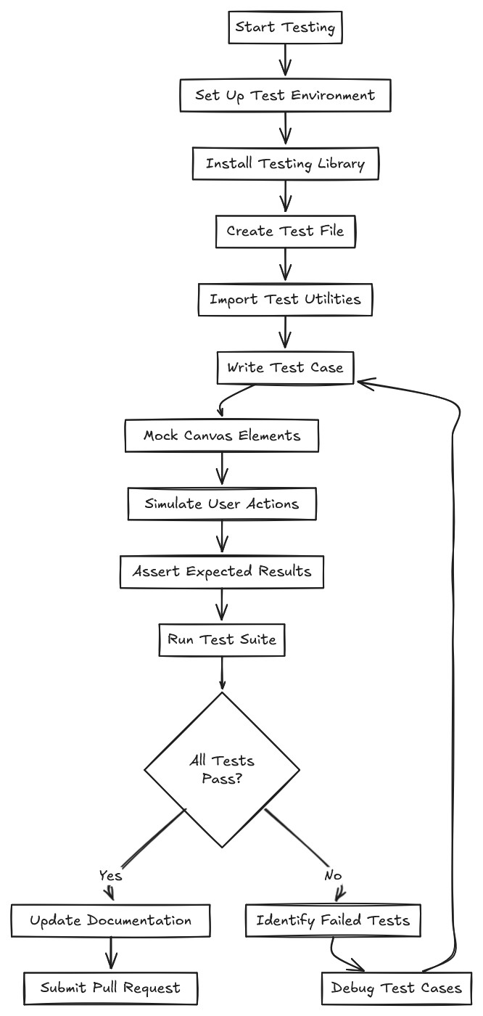

19


    - Development Setup and Execution
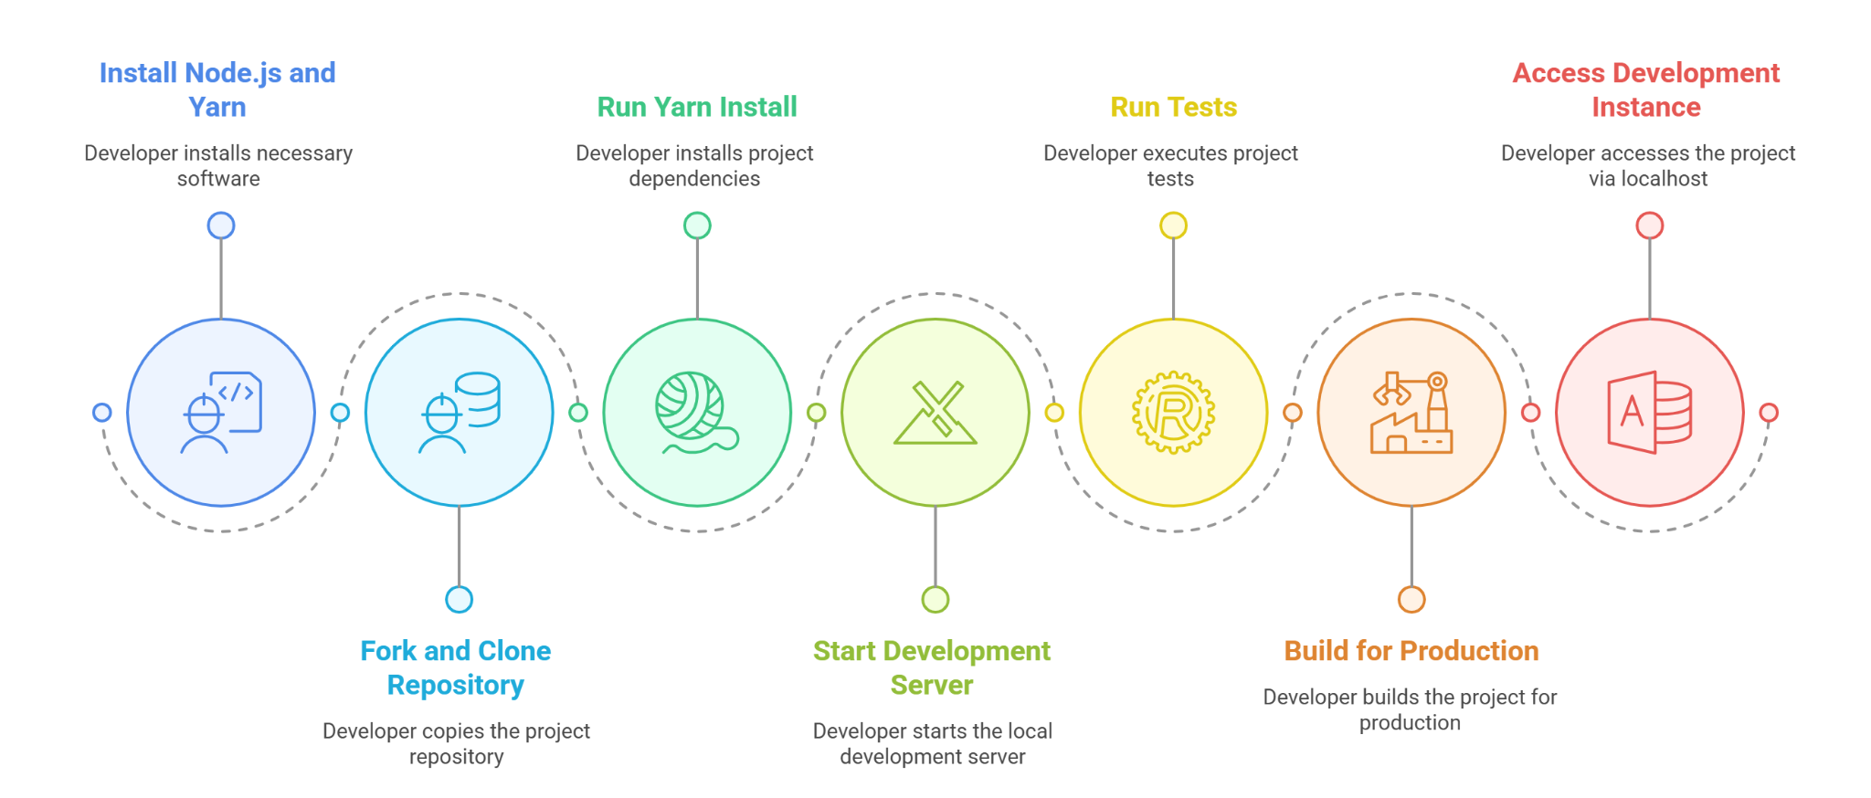

    - Collaborative Drawing Session
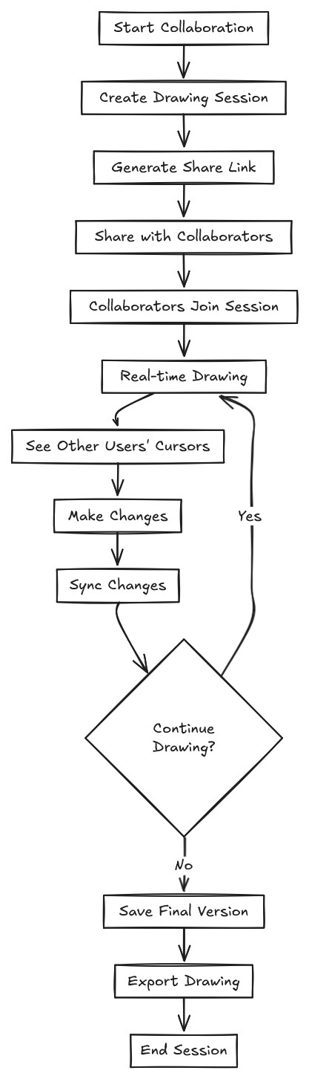

20


  - Excalidraw Package Interactions

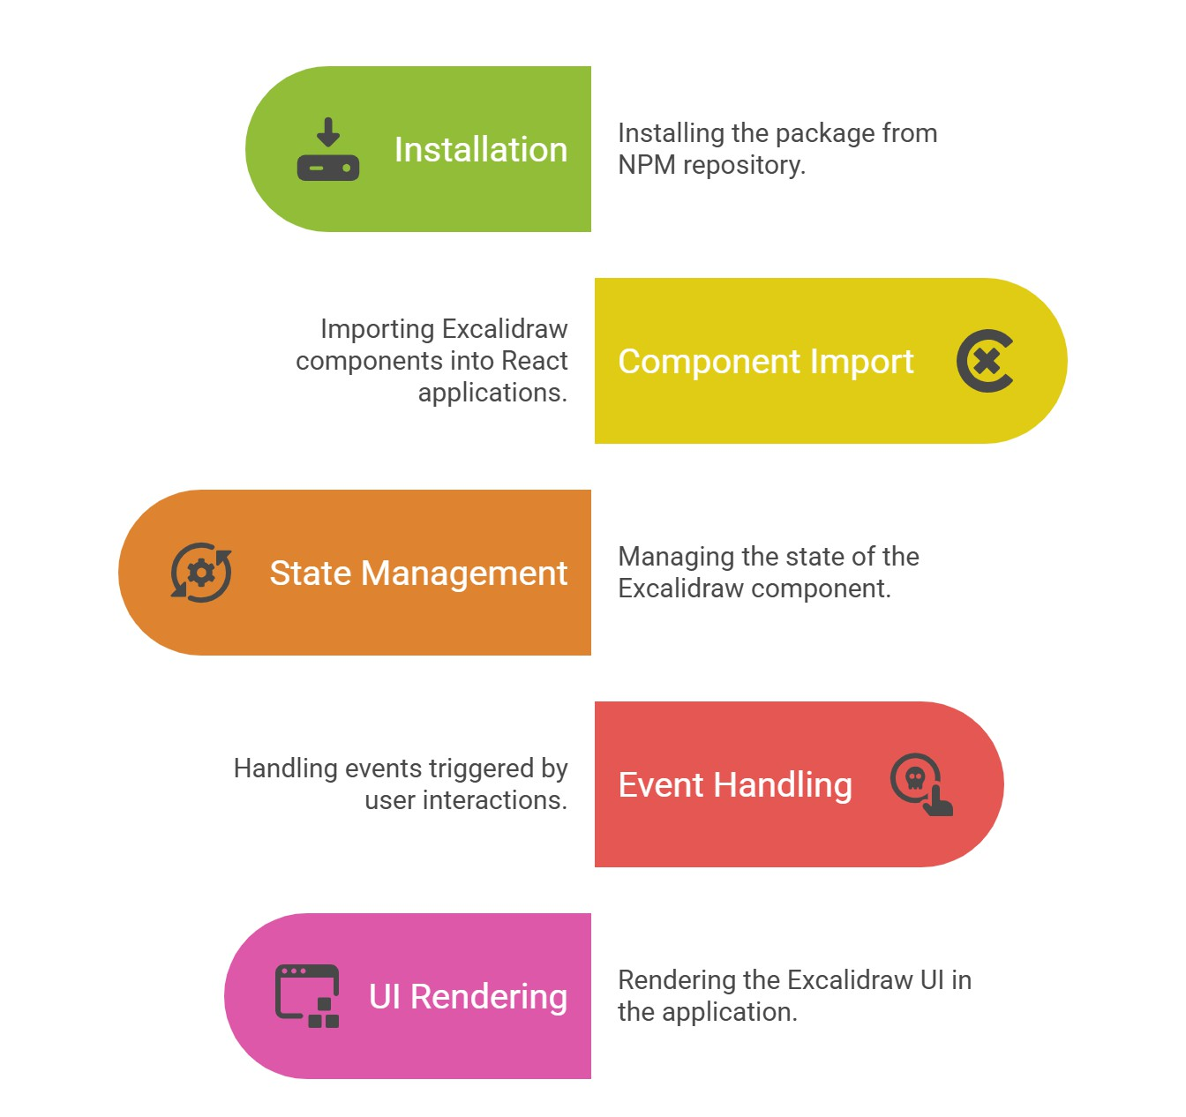

21


  - Developer Setting Up Development Environment
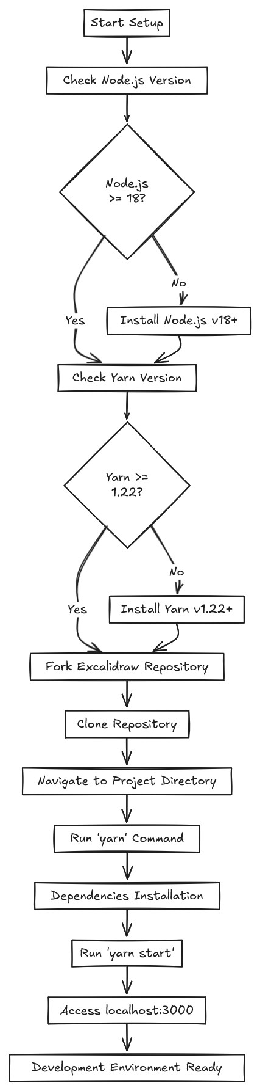

22


  - Hierarchy
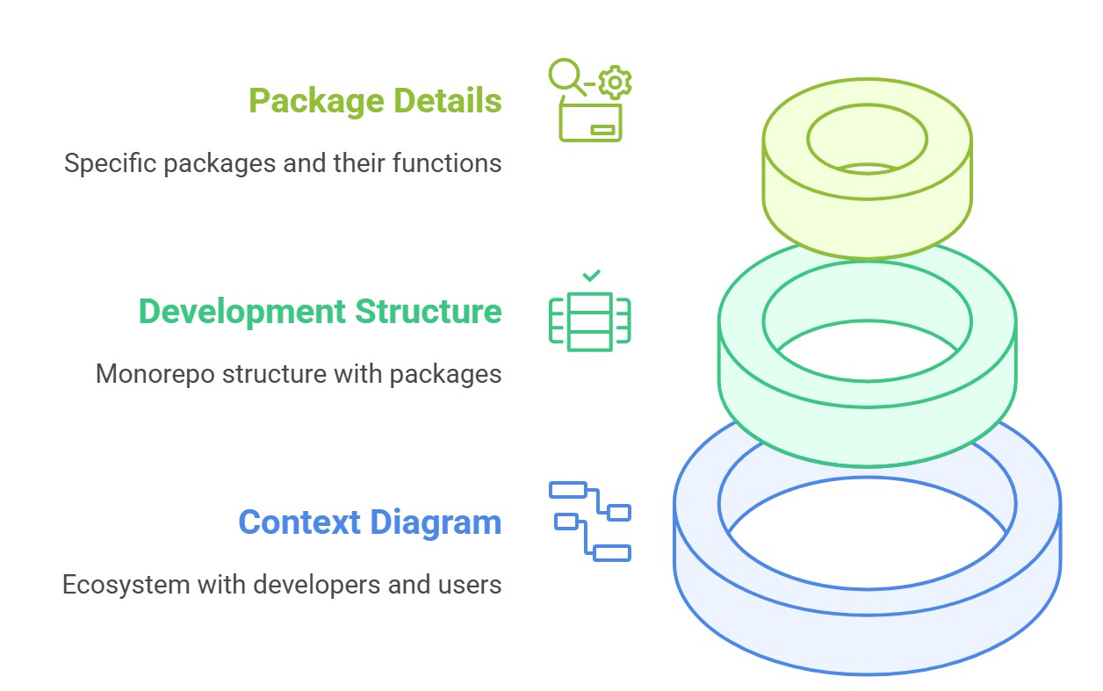

  - Development Workflow Timeline
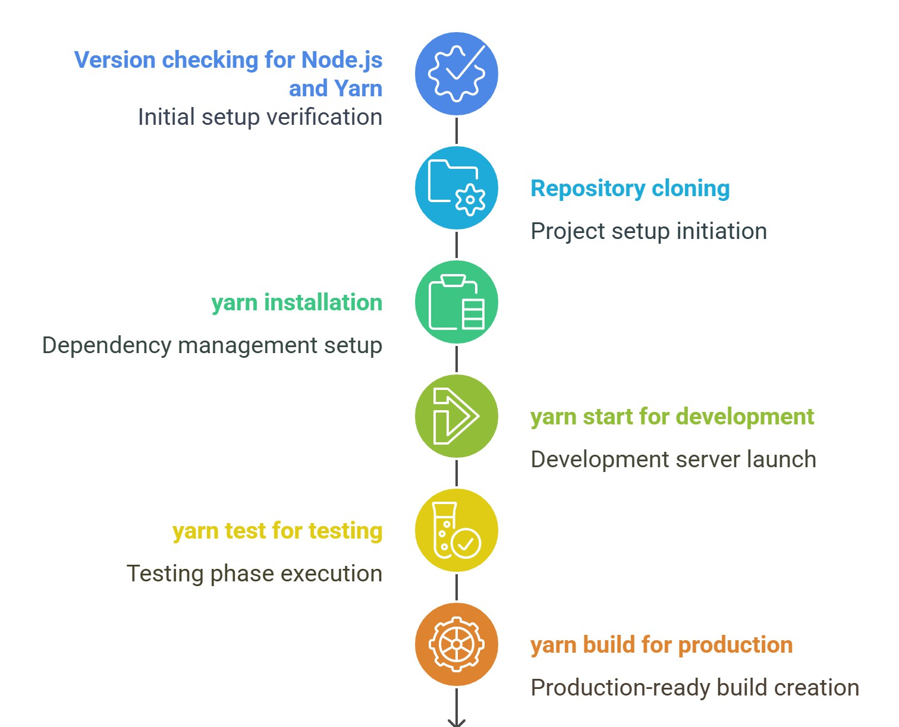

23


  - Data Flow Design
    - Level 0
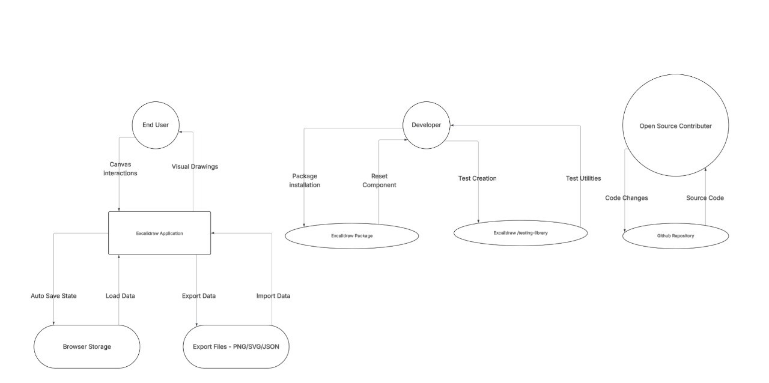

    - Level 2
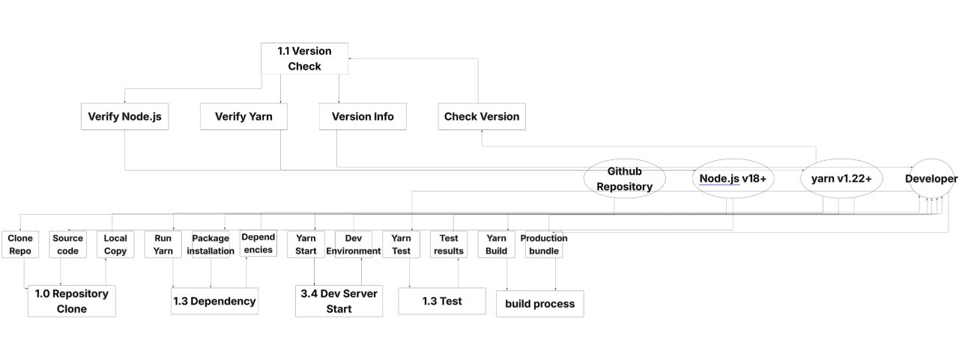

24


    - Level 0
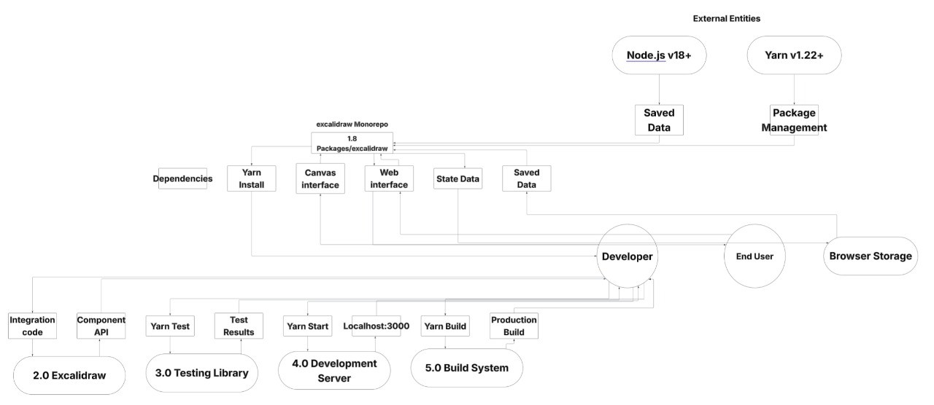

25


    - level 2
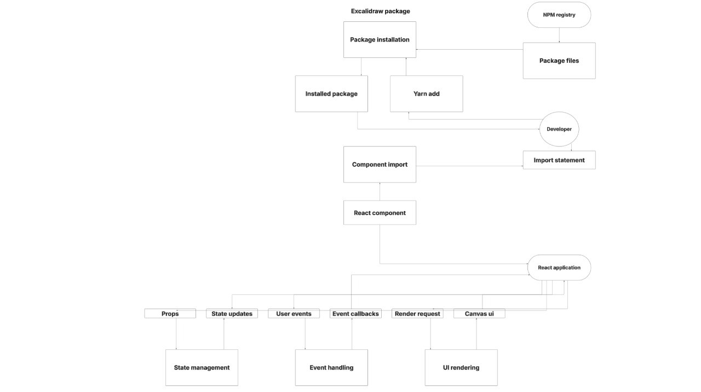

26


- Development

Code Structure & Repository Overview
Excalidraw is an open-source project hosted on GitHub. It follows a modern JavaScript/TypeScript React-based architecture. Here's a breakdown of the main directories in the project:
bash CopyEdit
/public → Static assets (e.g., icons, fonts)
/src
/components → React UI components (Toolbars, UI Panels)
/scene → Core canvas and element rendering logic
/data → App state and default values
/packages/excalidraw → Embeddable Excalidraw component

Development Environment Setup
To run and develop locally:

bash CopyEdit
# Clone the repository
git clone https://github.com/excalidraw/excalidraw.git cd excalidraw

# Install dependencies yarn install

# Run the dev server yarn start

Local development server will launch on http://localhost:3000.

27


  - Main Technologies Used

Technology | Role in project
React.js | Core UI framework
TypeScript | Type-safe JavaScript
RoughJS | Drawing library for hand-drawn visuals
Zustand | State management (lightweight alternative to Redux)
WebSockets | Used for collaboration features
Yarn | Package manager

Component Implementation
    - Excalidraw React Component
jsx CopyEdit
import { Excalidraw } from "@excalidraw/excalidraw";

export default function App() { return (
<div style={{ height: "600px" }}>
<Excalidraw />
</div>
);
}

This allows developers to embed Excalidraw into any React app easily.

Customization Possibilities
You can modify:

- Tools: Add new drawing tools to the toolbar
- Themes: Override styles or switch to dark/light mode
- Callbacks: Use onChange or initialData to control data flow
- Localization: Add support for other languages via i18n setup

28



Contribution Workflow
To contribute:

- Fork the GitHub repo.
- Create a new feature branch.
- Make changes and test thoroughly.
- Submit a pull request with clear description.
- PR reviewed and merged after passing CI checks.

29


- Software Testing
  - Test results and debugging

    - Entering wrong password or username
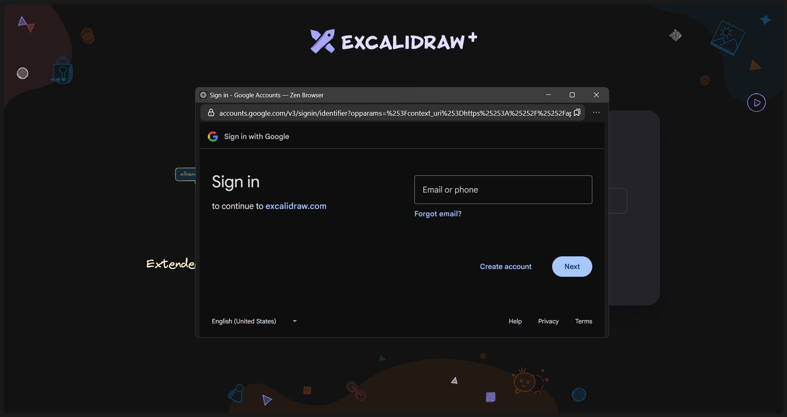

    - Checking if all the features are working

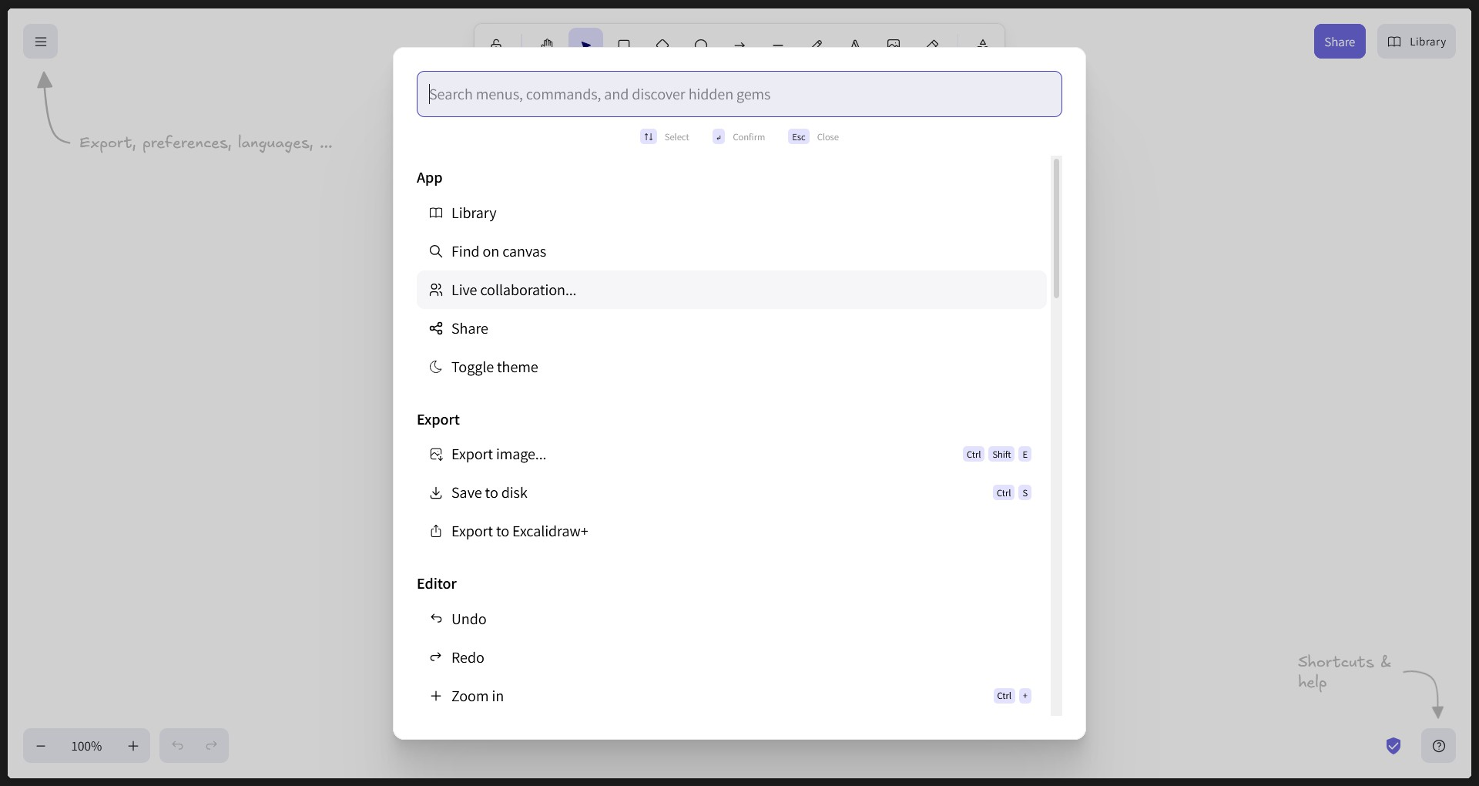

30


    - Testing all the tools Excali draw offers
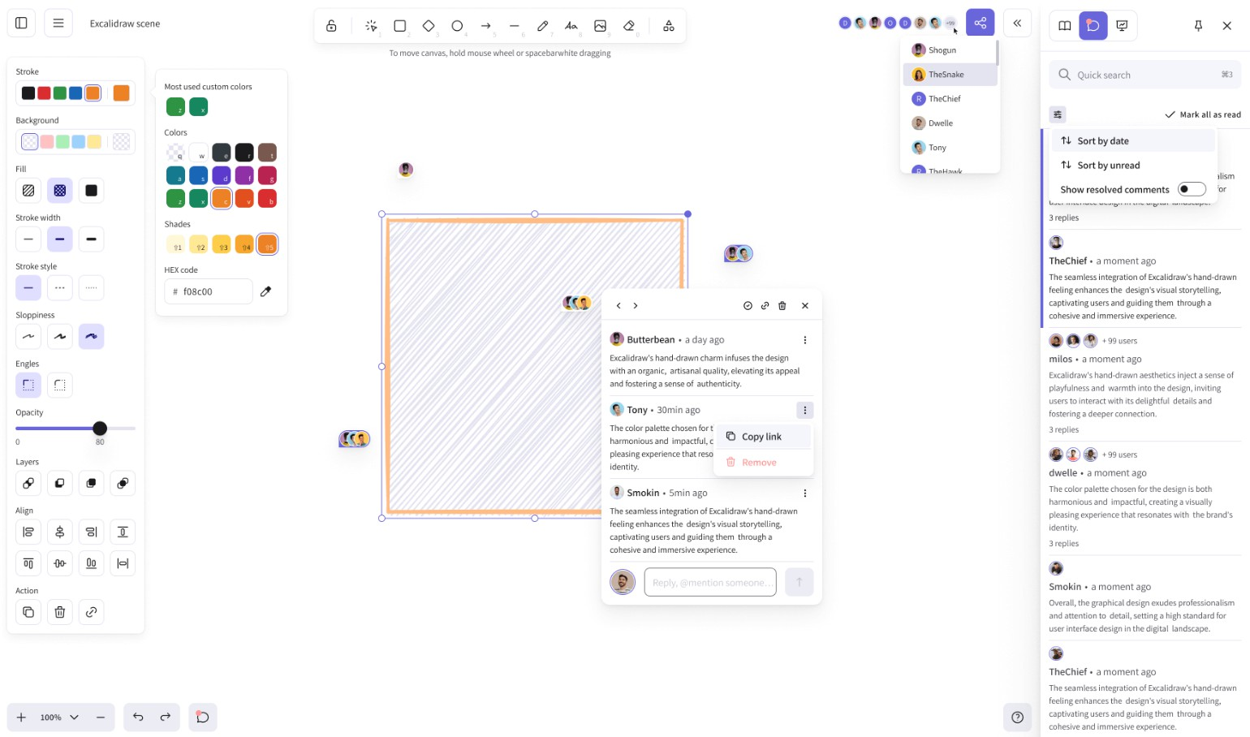

    - Checking if it runs on Chrome
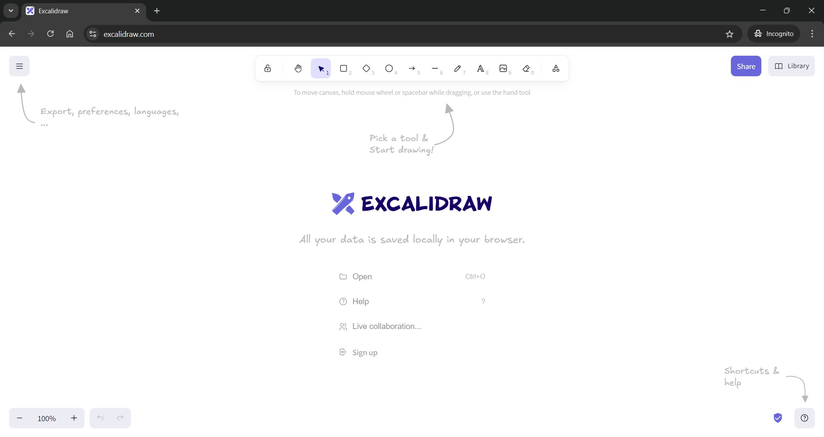

31


    - Checking if it runs on Firefox
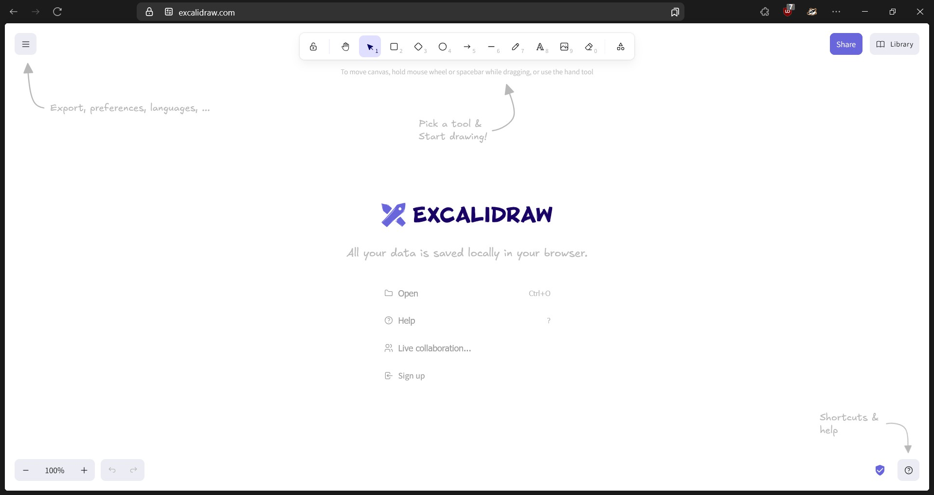

    - Checking if it runs on Mac

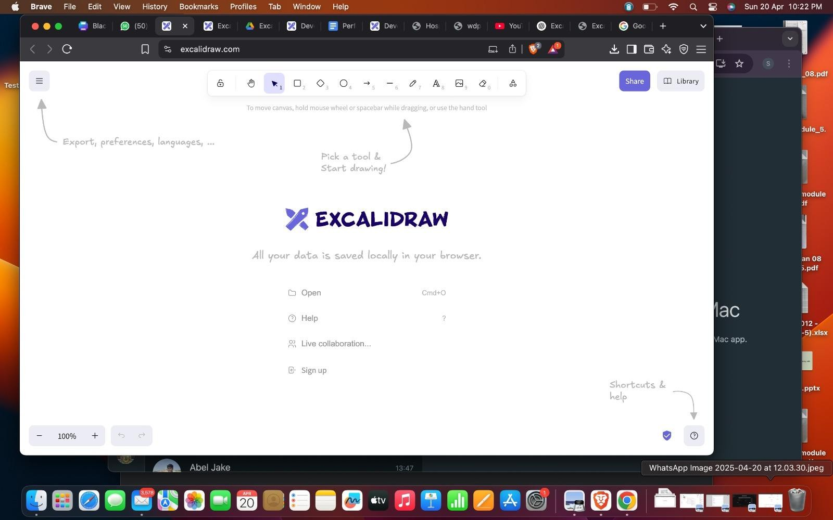

32


- Project Demo
  - Screen shots
    - Login Page
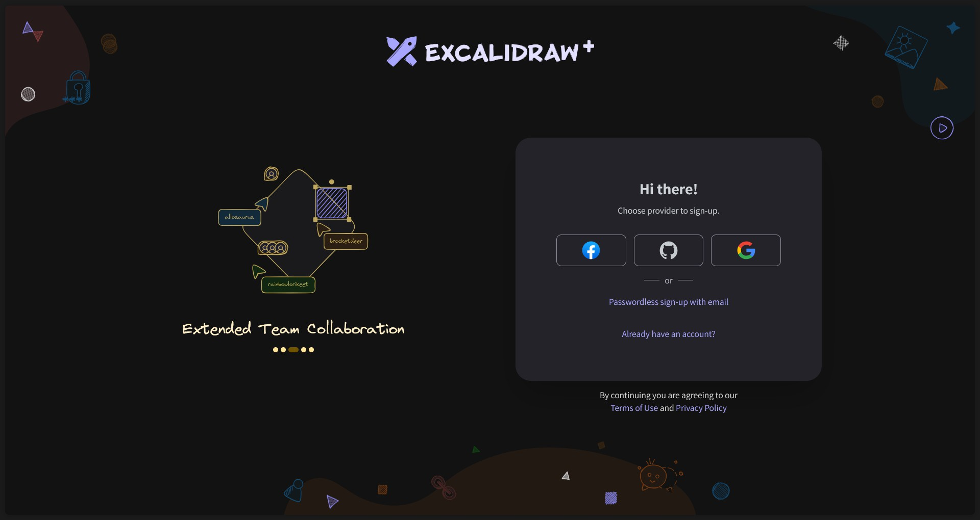

    - Passwordless sign-up

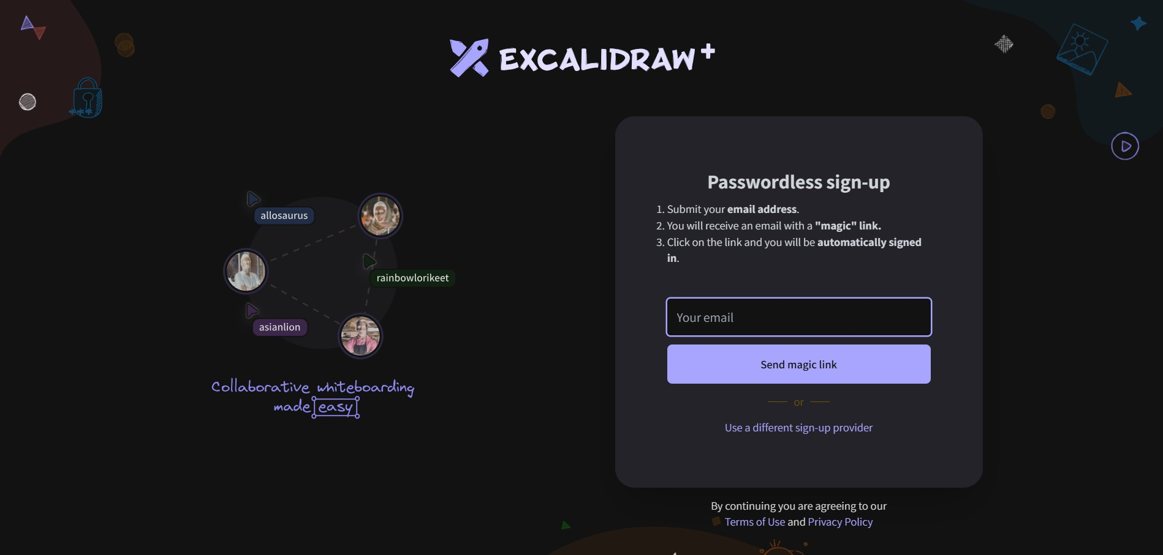

    - Logging in with email

33




    - Home page

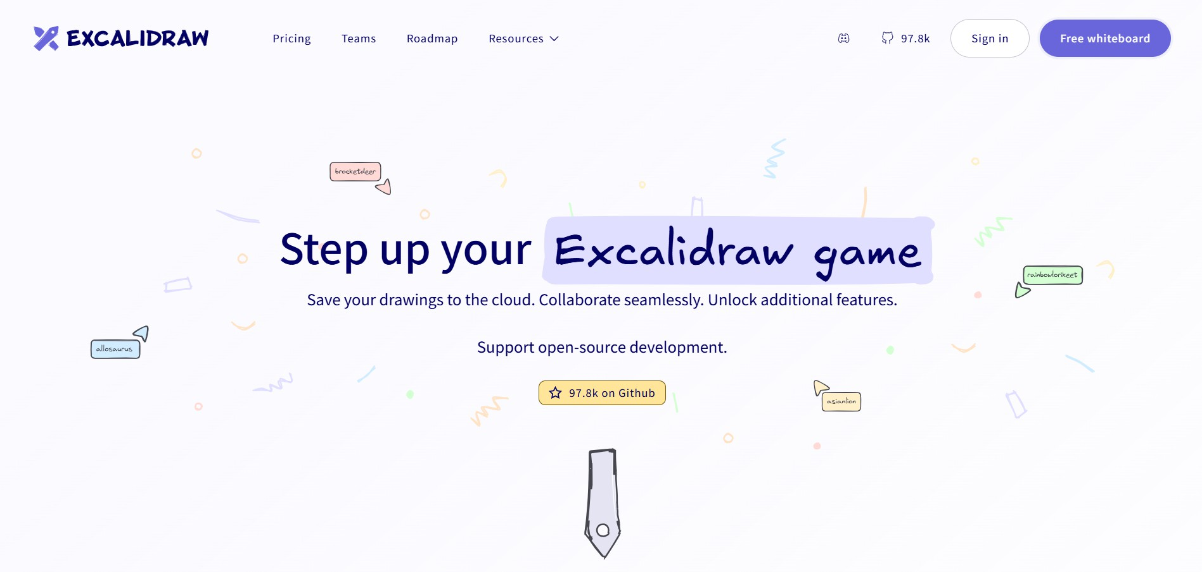

    - Preferred languages, shortcuts and tools

34


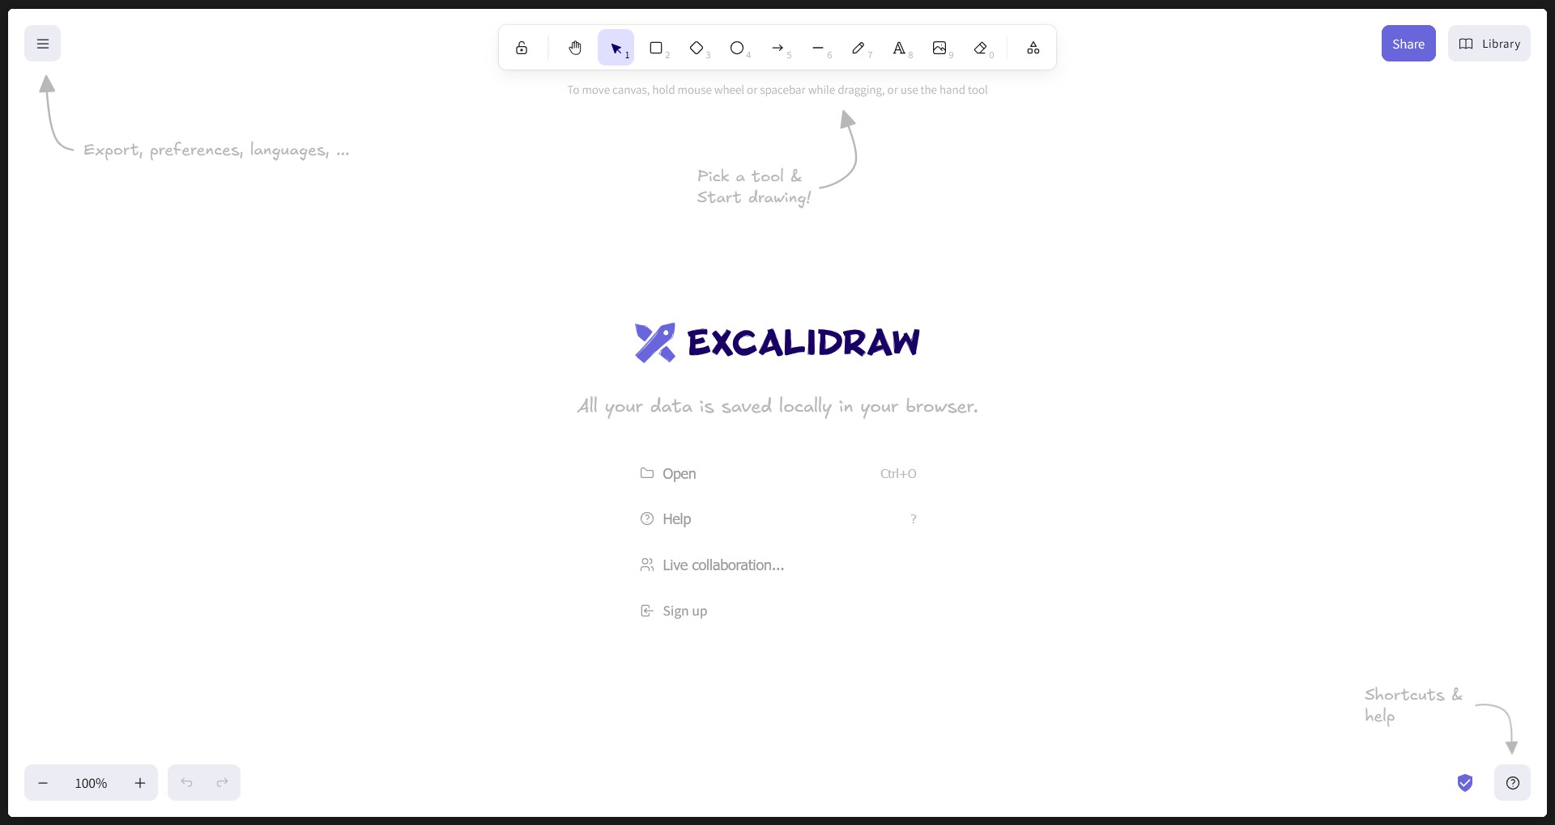

    - Scrolling through different commands



    - Using “live collaboration” to invite friends/team members

35


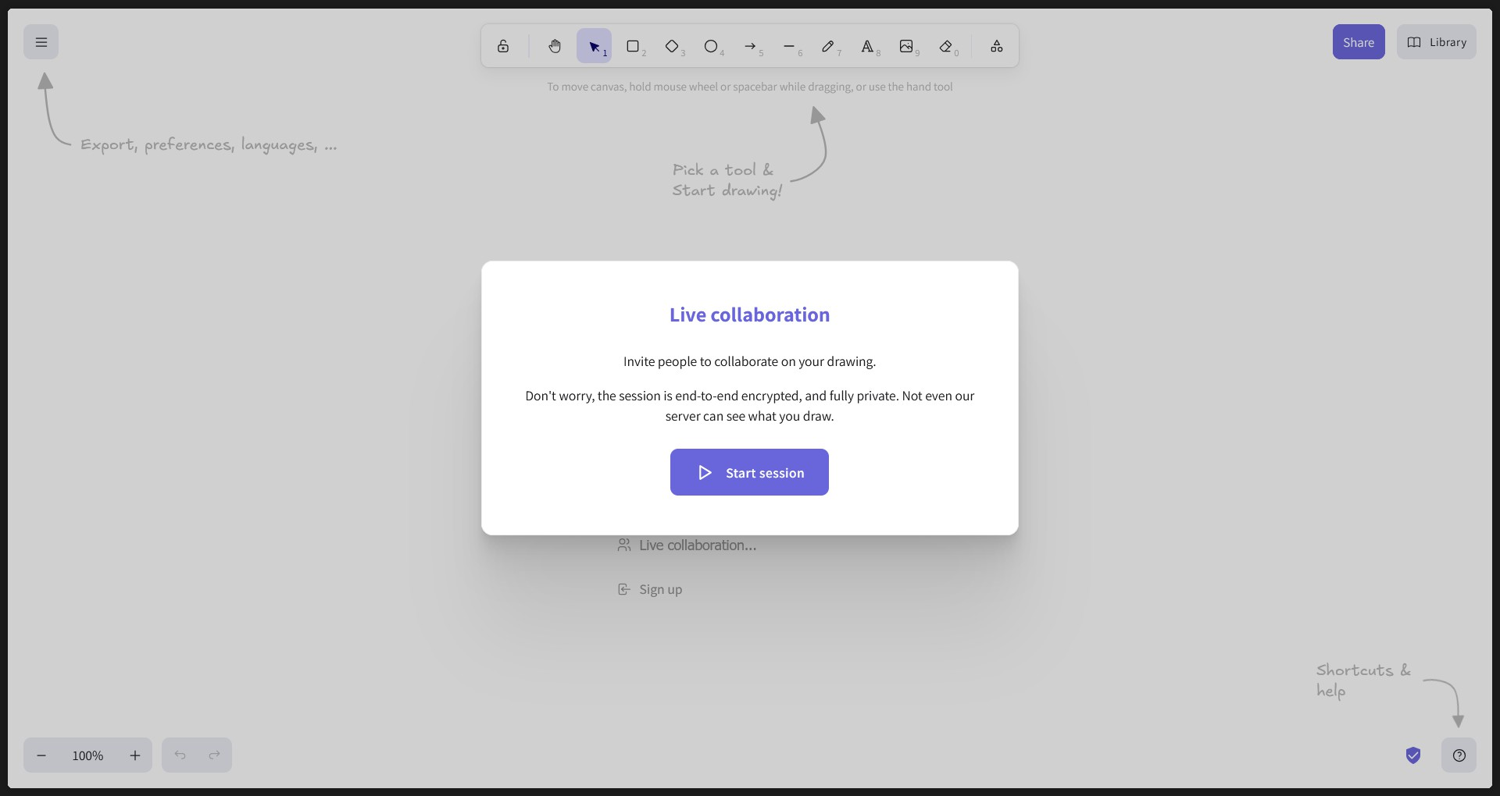

    - Creating a design



36


Conclusion

This report has thoroughly examined the Excalidraw tool from a software engineering perspective. It has covered essential aspects of the tool's architecture, development workflow, and integration capabilities. The analysis included a breakdown of user roles (developers, end users, and contributors), system requirements, functional behavior, and various technical features.
Excalidraw stands out as a highly extensible, open-source whiteboard tool built using modern
technologies such as React, TypeScript, and npm. Its simple yet powerful UI enables users to create hand-drawn-style diagrams effortlessly, making it ideal for ideation, planning, and real-time collaboration.
From a developer's standpoint, Excalidraw provides a well-documented API and modular component design, allowing seamless embedding into third-party React applications. The tool also supports offline access, automatic saving, export functionality, and collaboration through self-hosted backends or
services like Firebase.
From a software engineering angle, the project showcases:
- Clean architectural design with a focus on performance and maintainability
- Effective use of React components and hooks for UI reactivity
- Collaborative editing features, enhancing its utility for remote teams
- Robust testing and continuous integration pipelines to ensure code reliability

Furthermore, Excalidraw’s thriving open-source community encourages contributions, making it not just a drawing tool, but also a great learning platform for frontend developers.
In conclusion, Excalidraw is a robust, scalable, and developer-friendly tool. It effectively
demonstrates modern web development practices while solving a real-world problem: enabling teams to communicate visually and collaboratively through a digital whiteboard experience.

37

